Enabling notifications using IoT rules in AWS

|  |  |
| --- | --- |
| Title | Enabling notifications using IoT rules in AWS |
| By | Meenakshi Murugappan |
| Student Id: | L00156569 |

# Summary

This document describes enabling the notifications using IoT rules in AWS

It describes the following tasks:

1. Publish a topic to AWS IoT rules.
2. Create a rule to subscribe to the topic to understand the device temperature.
3. Push the email notification if the temperature is normal than the standard range.

Contents

Summary 1

Resources and Prerequisites 3

Introduction 3

Steps 4

Problems Faced 6

Conclusion 6

References 7

# Resources and Prerequisites

1. Valid AWS credentials to sign in to the AWS console to access the IoT core services
2. Valid IBM cloud account to install the node-red app.

# Introduction

This document provides the steps to enable AWS Simple notification service (SNS) [[1]](https://aws.amazon.com/sns/) using IoT Rule actions. The example used for this document is to push the temperature from IBM Node-Red and MQTTfx java client to AWS IoT core, simulating the SME for cold storage temperature sensors and if the temperature of the device is greater than normal range using query statement.

**Figure 1: Notification of User in case of any discrepancy in temperature using Amazon SNS in AWS IoT core.**

# Steps

1. Login to AWS Console and navigate to IoT core service to create a rule.

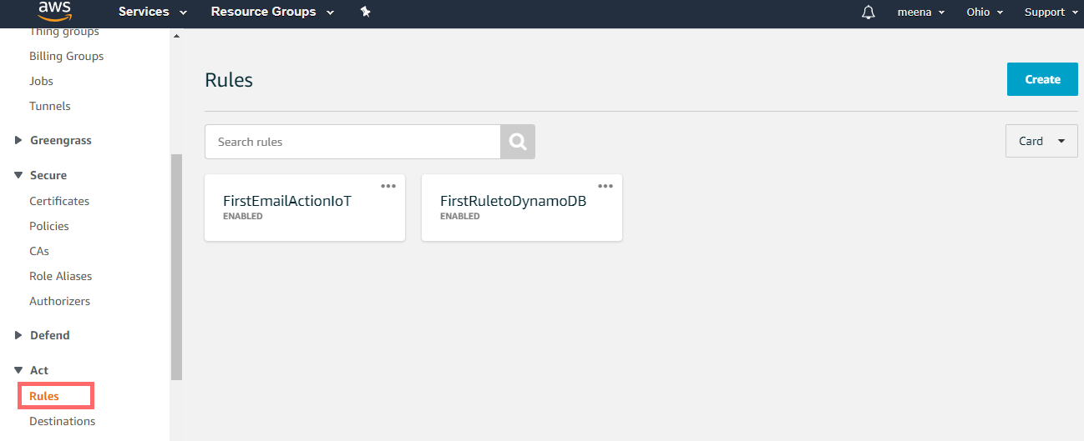

1. Click “Create” rule button at the top, Provide the name and description.

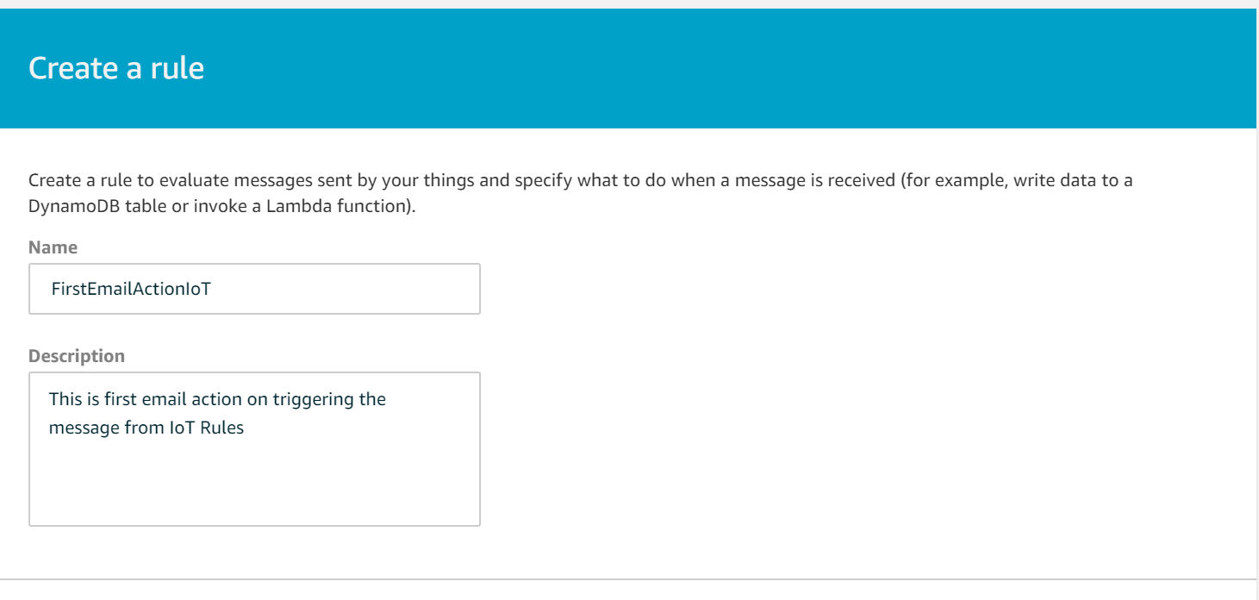

1. Add the rule query statement to subscribe to the topic published from the device sensor to push notification to Amazon SNS. Refer to this link [[3]](https://docs.aws.amazon.com/iot/latest/developerguide/iot-sql-reference.html?icmpid=docs_iot_console) to understand in detail of Rule query statement.

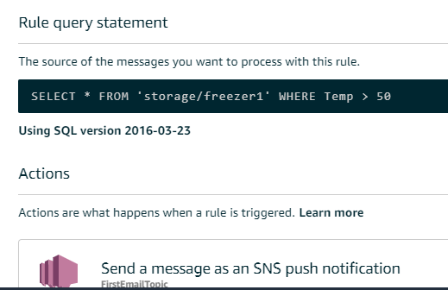

1. Create an action to use the Amazon simple notification service (SNS).

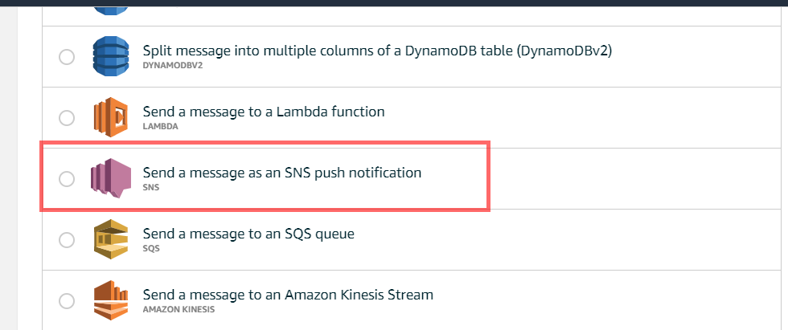 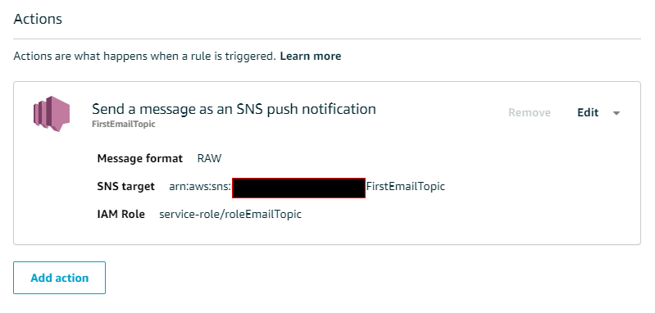

1. Once the action is created, Configure the topic as per the below image.

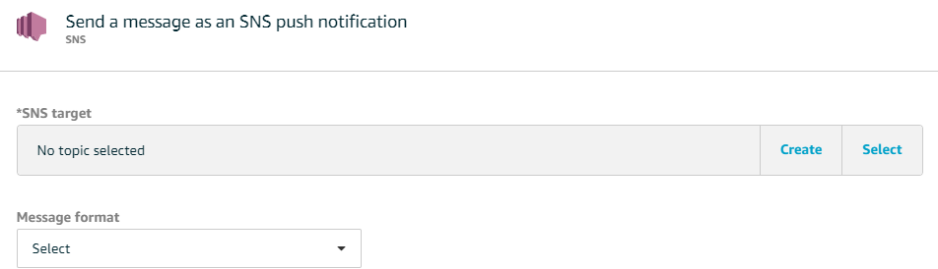

1. Once the SNS target is created, attach, or create an IAM role.

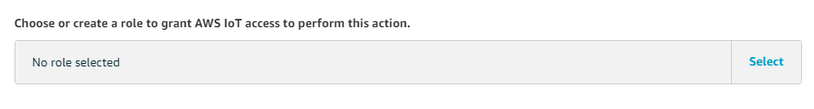

1. Once the IAM role is created for email, verify the same by navigating to IAM services as shown below and correct configurations are added as shown in the below image or see the Policy JSON in the GitHub.

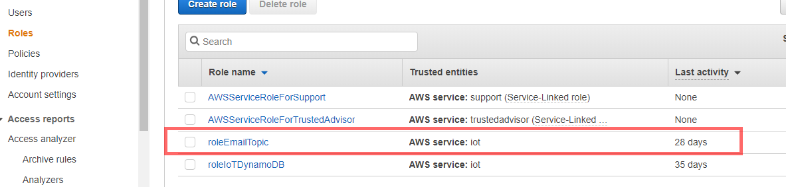

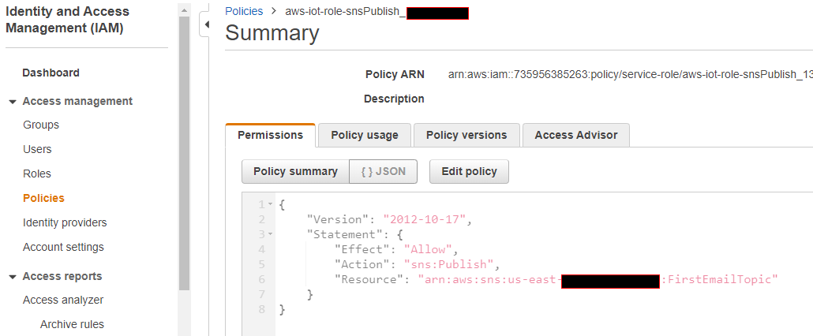

1. Once the action is created in the IoT rule, click to add a subscription to an email.

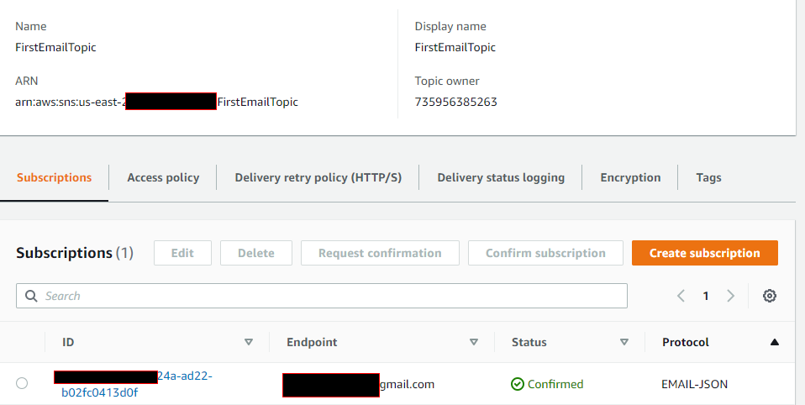

1. Verify the subscription automated email sent by the AWS, before receiving the notification.

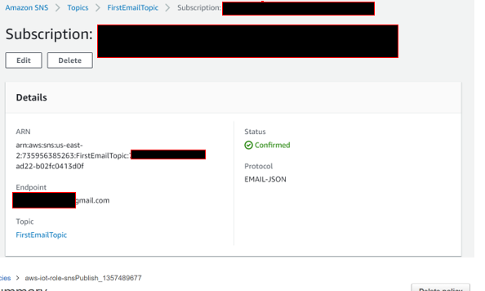

1. Verify by publishing the temperature device as shown below, If the message contains a temperature greater than 50, the email will be notified or else no notification will be sent.

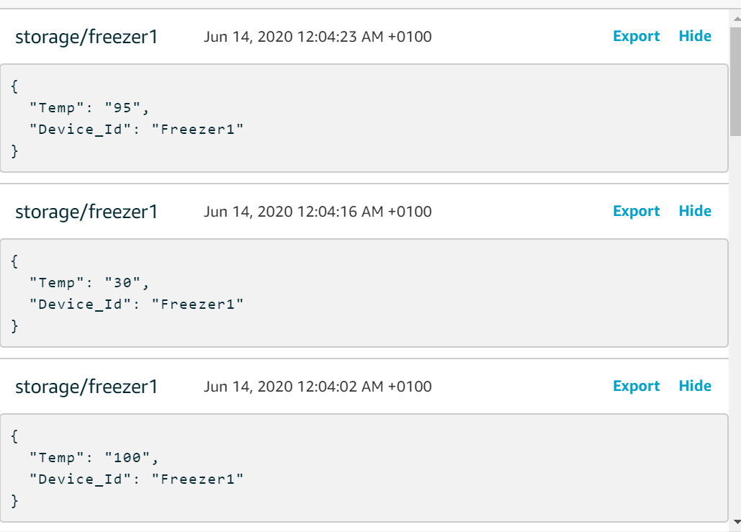 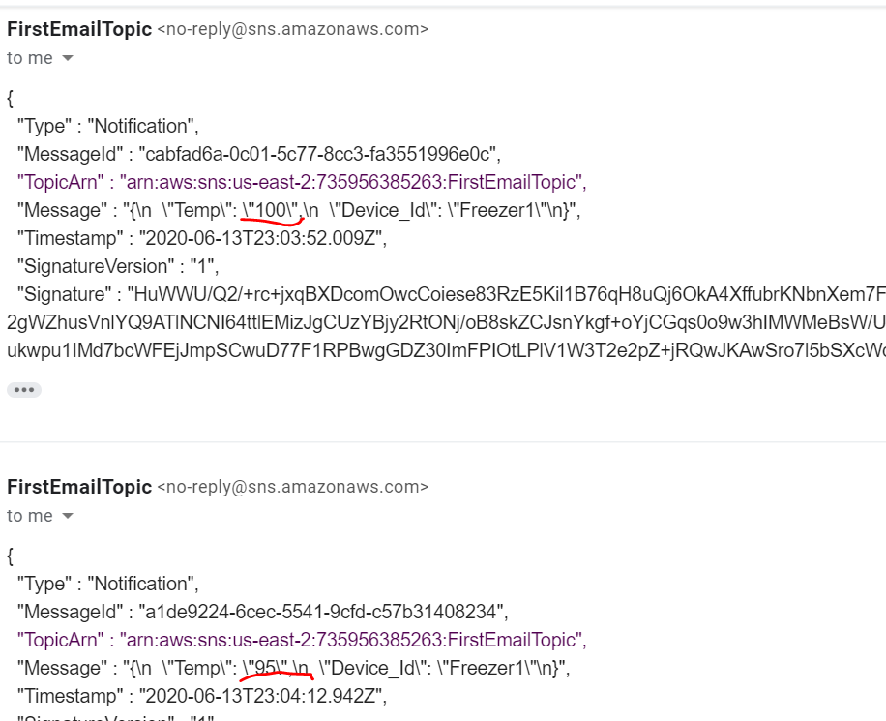

# Problems Faced

1. Ensure the correct IAM policy is attached to IoT core as per step 9 or the notifications will not be received.
2. Verify the Rule query statement to ensure the correct query is used for notification, there can be an error in the query.
3. Once the Email rule, we need to create a subscription, verified, and confirmed or else the emails will not be received.

# Conclusion

The purpose of the above exercise is to send the notification in case of malfunctioning the devices in the industrial world, this will help to prevent a huge economic loss in the business that is the main advantage of IoT core services in the cold factory for an SME.

# References

[1] Amazon Simple Notification Service, <https://aws.amazon.com/sns/>, 03-July-2020.

[2] AWS IoT Core, <https://aws.amazon.com/iot-core/>, 01-June-2020.

[3] AWS IoT SQL reference, <https://docs.aws.amazon.com/iot/latest/developerguide/iot-sql-reference.html?icmpid=docs_iot_console>, 18-June-2020